# Logistic App by Spring Boot

## Build jMetal for Logistic app

1. Right click at the jMetal project
2. Select *Run as -> Maven build…*

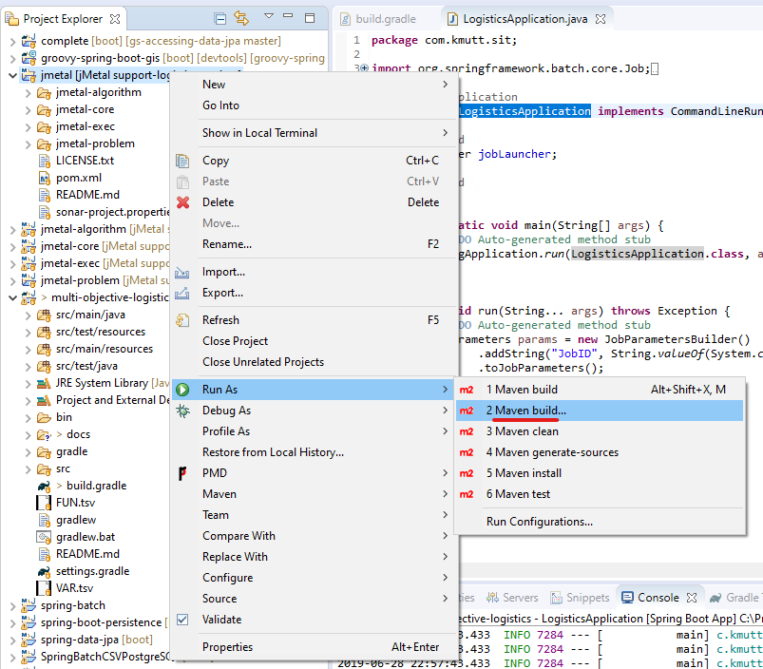

1. In Edit Configuration window, type “clean install -Dgpg.skip=true -DskipTests=true -Dmaven.javadoc.skip=true” in the Goals: field

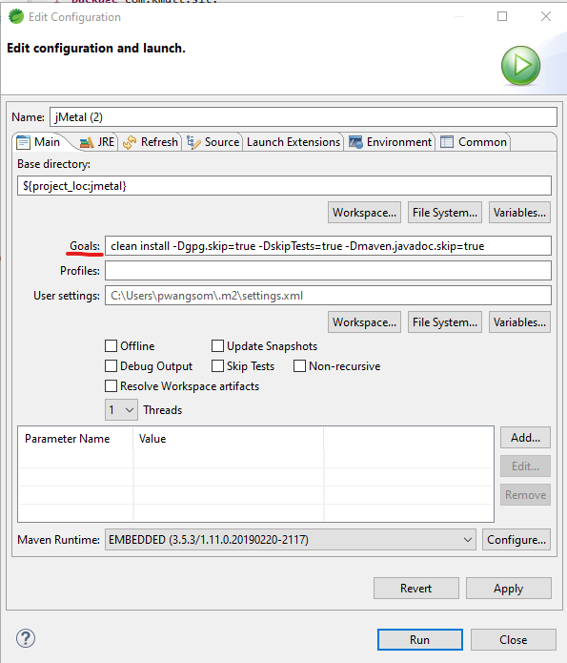

1. If jMetal is built successfully, console will show the messages as follows

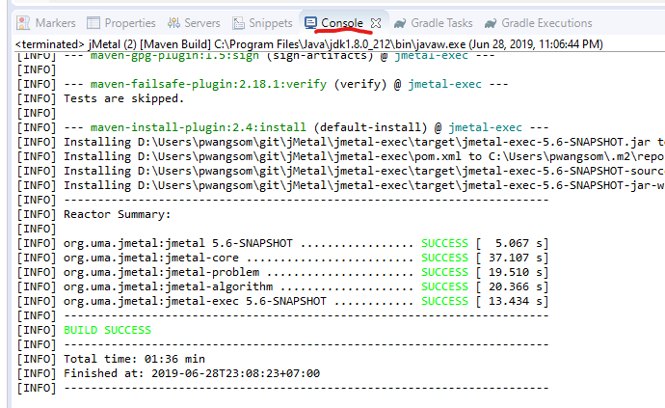

1. Warning: if jMetal is not built before running Logistics app, the error will occur as the following message. “Error: Could not find or load main class com.kmutt.sit.LogisticsApplication”

## Run Logistics app with the external property file

1. Right click at the Logistics app project
2. Select *Run as -> Run Configurations…*

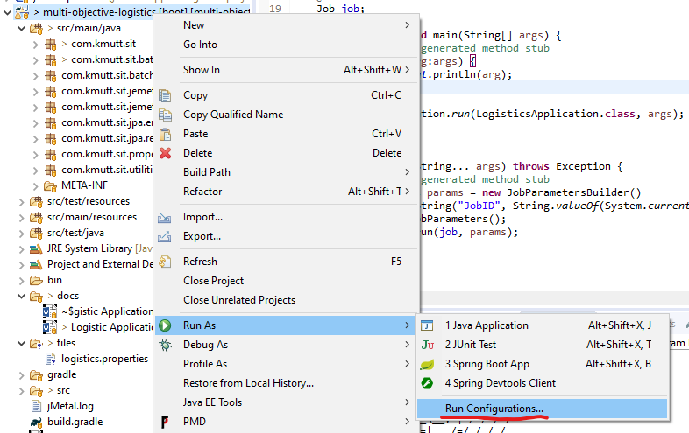

1. In Run Configurations window, click *Spring Boot App* then click *New Configuration* icon

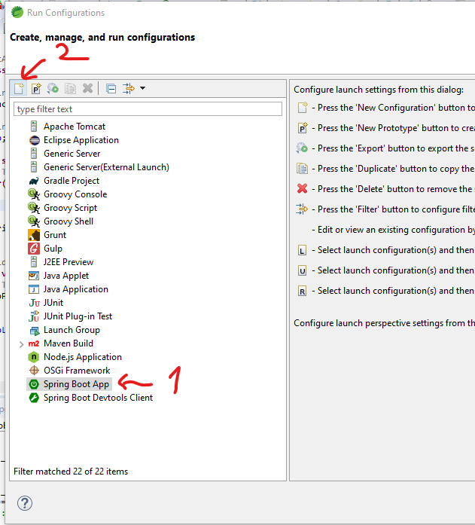

1. Type “LogisticsApplication” for Name and Main type, and select *multi-objective-logistics* for Project

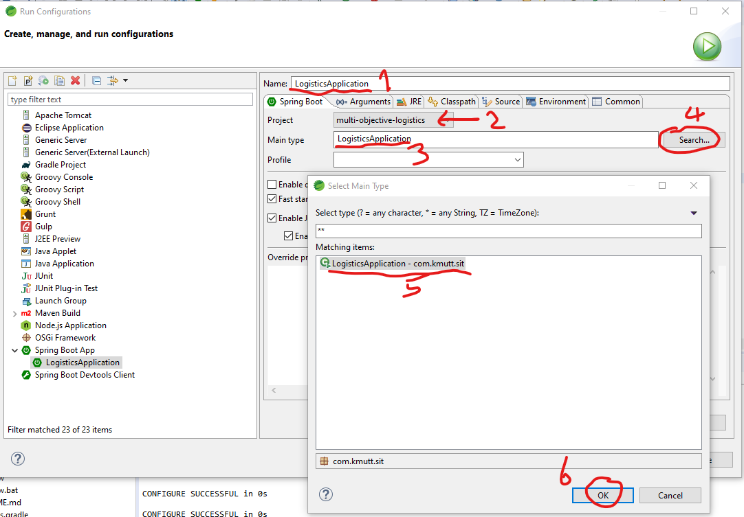

1. If we would like to refer the external file “logistics.properties” in the directory “D:\Users\pwangsom\git\multi-objective-logistics\files\”, we have to define runtime environment by clicking at Environment tab and then type variable as follows:
   1. spring.config.location classpath:/,file:///D:/Users/pwangsom/git/multi-objective-logistics/files/
   2. spring.config.name application,logistics

